-----Original Message-----
Amelia Tan/PACIFIC/BAX / SIN Manager Logistics Management Singapore 09/11/2006 09:54 AM
To: Darren Lee/PACIFIC/BAX@BAX, William DeAlmeida/PACIFIC/BAX@BAX, Ron Lee/PACIFIC/BAX@BAX, Bobby Tan/PACIFIC/BAX@BAX
cc: EngKiat Kang/PACIFIC/BAX@BAX, Clarito Ablanque/PACIFIC/BAX@BAX
Subject: Re: Motorola Spares_loc setup for billing report [clarification on Fixed/Overflow]

Hi Darren / William / Ron,

based on the proposal to Mot, take a look at the nos below for New cap covered under Fixed and Overflow (assuming 100% utlization of Site C) the key area that may invite dispute is Shelving, the total fixed allocated is only 208 location and max possible overflow chargeable is 1629 loc

we may want to check if each location is size 0.6x0.6x1m
if it is smaller, then we need to calculate as 2 shelving loc = 1 ctn rate etc

pls advise asap, tks!

A) Proposed to Motorola
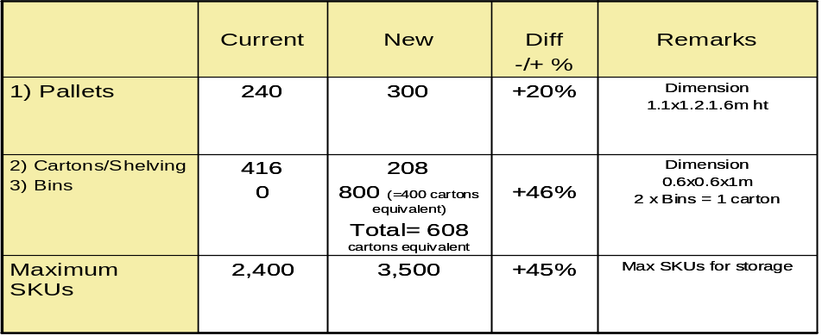

B) Fixed / Overflow spread
